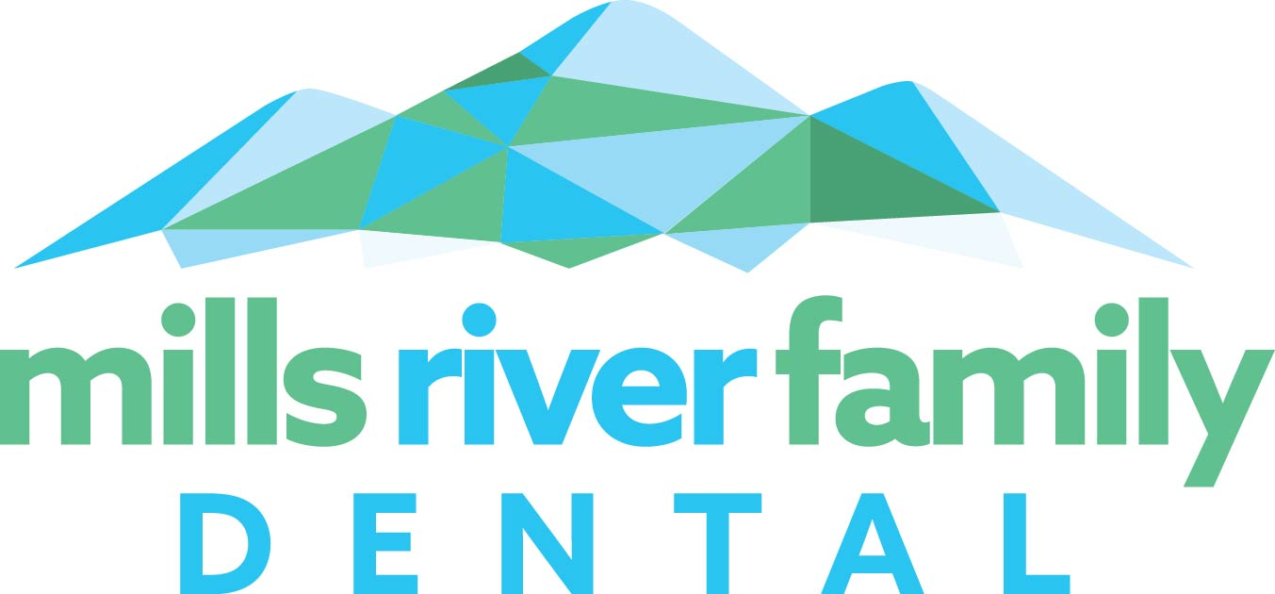

DENTAL RECORD RELEASE FORM

Patient Name to Transfer: ____________________________________________________

Date of Birth: ___________________Phone Number: _________________

Other Family Members to Transfer: ___________________________________________

Previous Dentist or Practice Name: ____________________________________________

Address: ____________________________________ City/St./Zip: ______________________

Phone Number: __________________

Patient Rights:
- I have the right to revoke this authorization at any time.
- I may inspect or copy the protected health information to be disclosed as described in this document.
- Revocation is not effective in cases where the information has already been disclosed but will be effective going forward.
- Information used or disclosed as a result of this authorization may be subject to redisclosure by the recipient and may no longer be protected by federal or state law.
- I have the right to refuse to sign this authorization and that my treatment will not be conditioned on signing.

Please forward any information and radiographs you may have on file.

I hereby give you permission to release all previous dental records.

Signature: _____________________________________________ Date: ________________

If records are digital, please email to: mrfdoffice@gmail.com
Or mail to:

Mills River Family Dental
3340 Boylston Hwy., Unit 30
Mills River, N.C. 28759
828-891-7999

